Linear Convection in 1D

Initial condition: Step function:

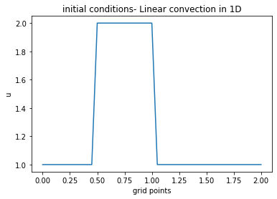

Discretization: Finite Difference Method: forward difference for time and backward difference for space

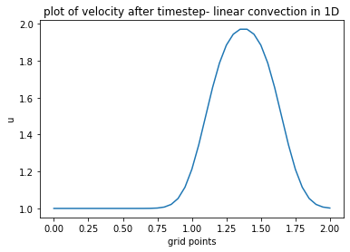

Nonlinear Convection in 1D:

Initial condition: Same initial conditions and discretization as linear convection.

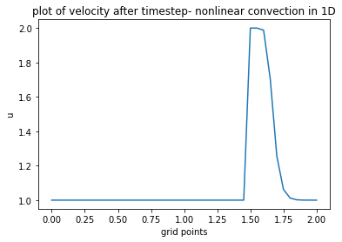

1D Diffusion Equation:

Initial condition: Hat function

Discretization: Central difference method- combination of forward and backward difference of the first derivative (since it involves a second order derivative)

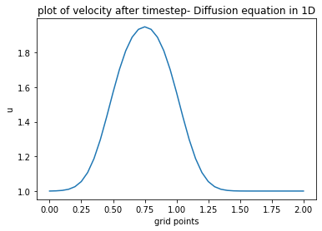

Burgers’ equation in 1D:

Initial condition: saw tooth function



Analytical solution of the initial condition:



Boundary condition: Periodic boundary condition:

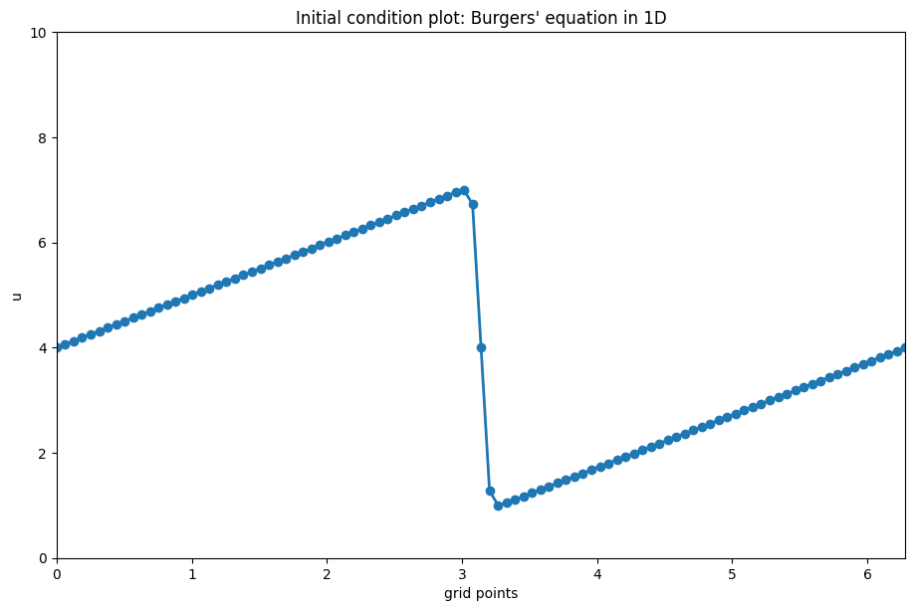

Applying the discretization and solving numerically by finite difference method and comparing with the analytical solution obtained from the initial condition solution:

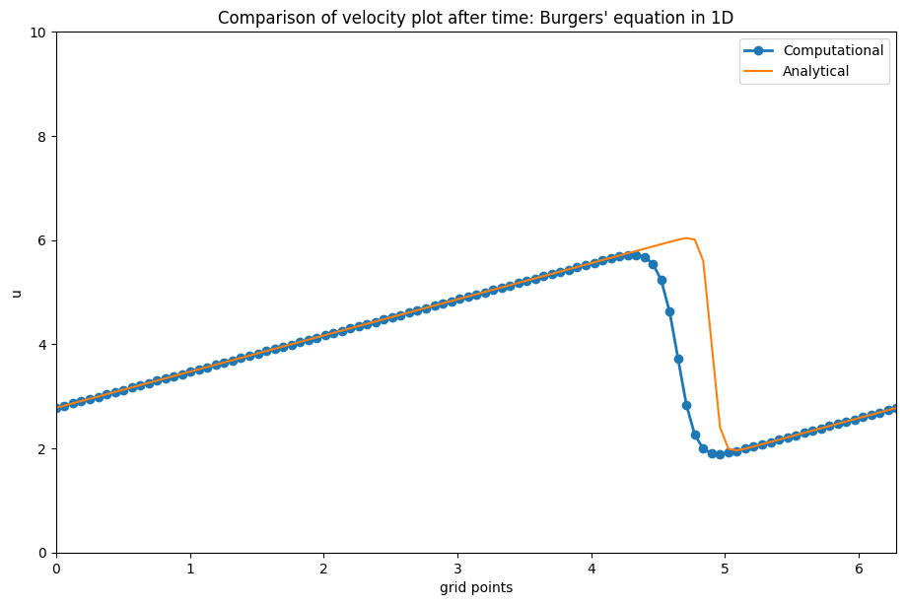

2D Linear Convection:

Same discretization with an additional subscript j

Initial condition: square function:

Boundary condition:

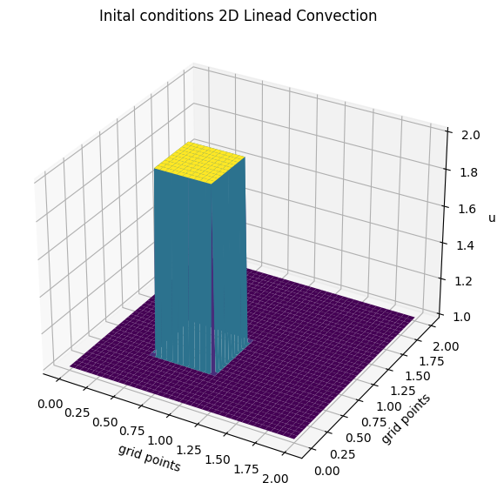

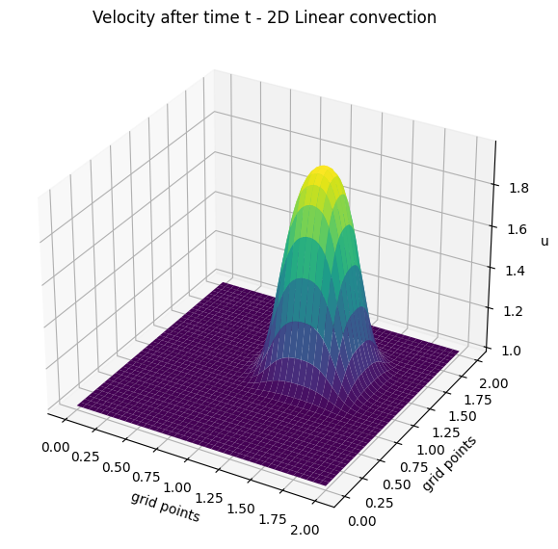

2D nonlinear convection

Initial condition: square function

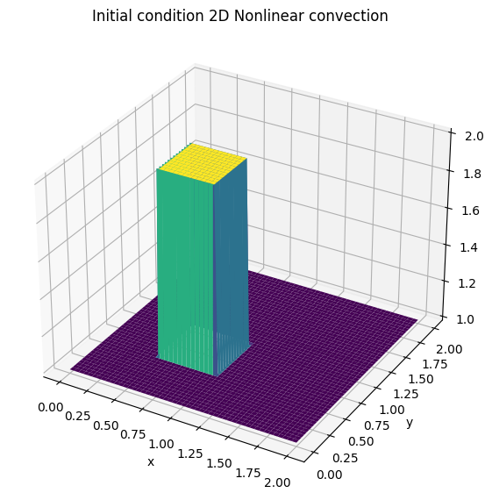

Boundary condition:

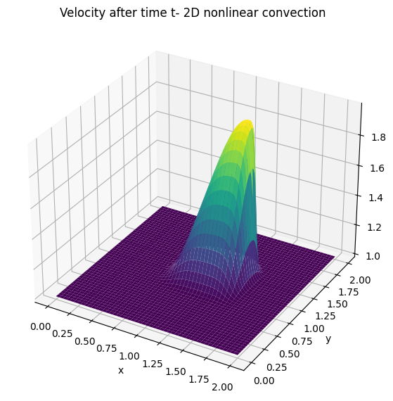

2D Diffusion equation:

Initial condition: square function:

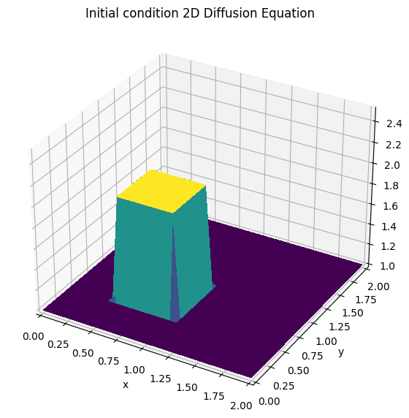

Applying finite difference:

Animation

2D Burgers’ equation:

Coupled set of PDE’s:

Initial condition: square function

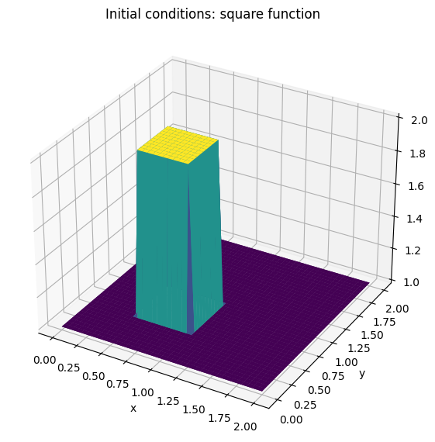

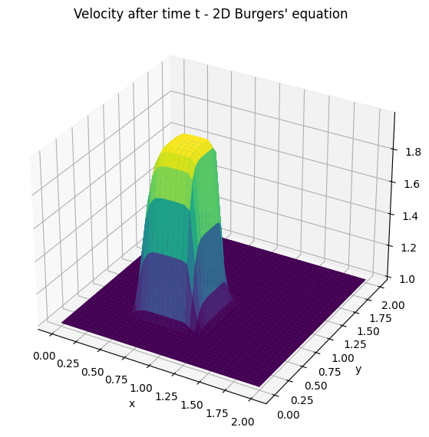

2D Laplace’s equation:

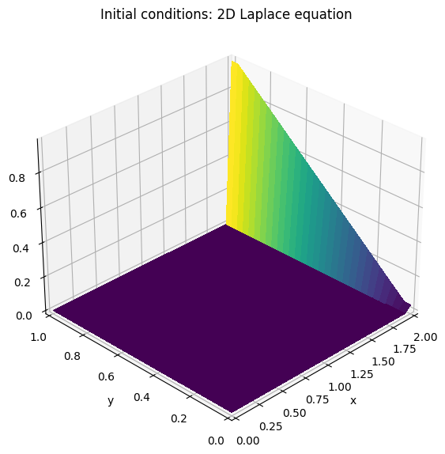

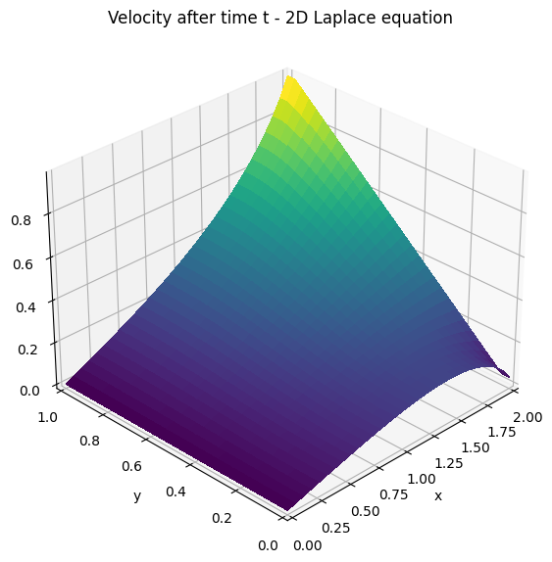

2D Poisson’s equation:

Animation

Navier-Stokes: Cavity flow

Quiver plot:

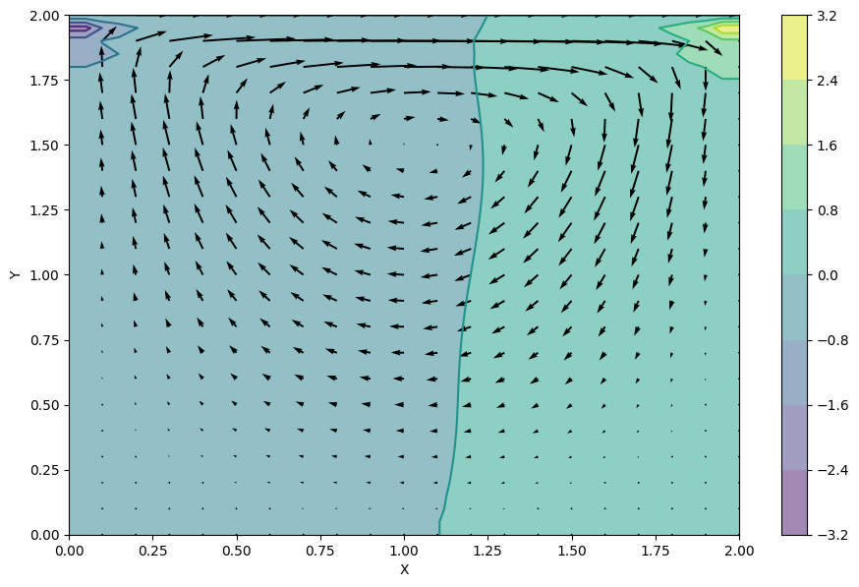

Stream plot:

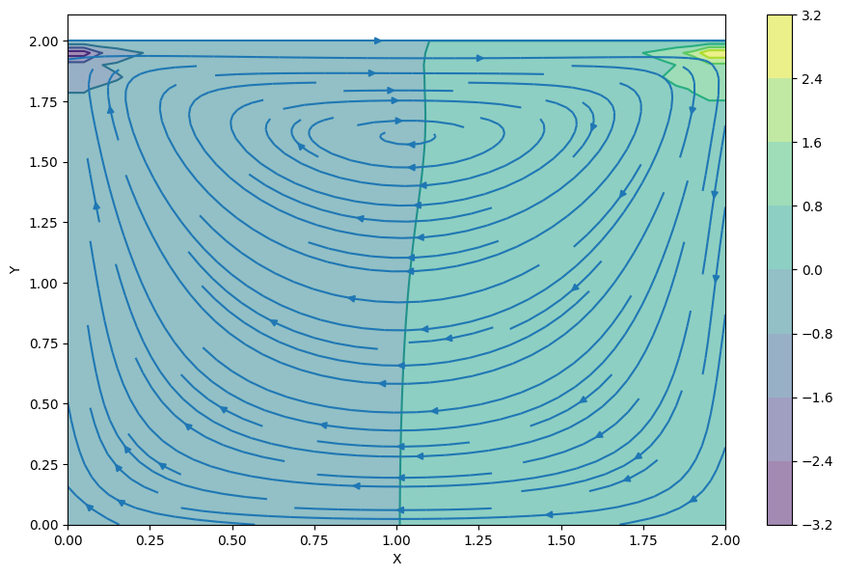

Animation

Navier-Stokes: Channel/pipe flow:

Quiver plot:

